Exam Preparation – Yr 11 ATAR PE Studies

16 copies of Question/Answer booklet

16 copies of Multiple choice answer sheet

16 booklets of lined paper (8 – 10 pages of lined paper in each booklet)

Spare lined paper



Semester 1 Examination, 2018

Question/Answer Booklet

PHYSICAL
Students, please place your name in this box
EDUCATION
STUDIES
ATAR Units 1 and 2

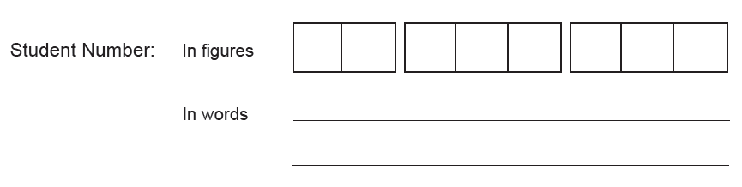

Time allowed for this paper
Reading time before commencing work: Ten minutes
Working time for paper: Two and a half hours

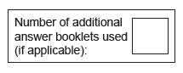
Materials required/recommended for this paper
To be provided by the supervisor
This Question/Answer Booklet
Multiple-Choice Answer Sheet
Extended answer booklet (lined paper)

To be provided by the candidate
Standard items: pens (blue.black preferred), pencils (including coloured), sharpener, correction fluid/tape, eraser, ruler, highlighters
Special items: non-programmable calculators approved for use in the WACE examinations

Important note to candidates
No other items may be taken into the examination room. It is your responsibility to ensure that
you do not have any unauthorised notes or other items of a non-personal nature in the
examination room. If you have any unauthorised material with you, hand it to the supervisor
before reading any further.

Structure of this paper

Section | Number of questions available | No. of questions to be attempted | Suggested working time (minutes) | Marks available
Section One:  Multiple-Choice | 20 | 20 | 20 | 20
Section Two:  Short Answer | 7 | 7 | 70 | 50
Section Three:  Extended Answer | 4 | 2 | 60 | 30
 |  |  | Total | 100

Instructions to candidates

- The rules for the conduct of this examination have been outlined. Sitting this examination implies that you agree to abide by these rules.

- Section One: Answer all questions on the separate Multiple-Choice Answer
Sheet. Use a blue or black pen or a B or 2B pencil.

- Section Two: Answer all questions.
Answers are to be written in this Question/Answer booklet using blue or black pen or a B or 2B pencil.

- Section Three: Answer two of the four questions available.
Answers to each question need to be written on the lined paper booklet provided with the question number clearly marked.
Use a new page for each question.

SECTION ONE: MULTIPLE CHOICE (20 marks)

Record an answer for questions 1 – 20 by marking your choice on the separate Multiple-Choice Answer Sheet using a blue or black pen or a B or 2B pencil. Each question is worth one mark.

If you make an error, follow the instructions given to you on the Multiple-Choice Answer Sheet.

Suggested working time for this section is 20 minutes.

1. The Inferior Vena Cava carries:

- Oxygenated blood from the body to the heart
- Deoxygenated blood from the body to the heart
- Oxygenated blood from the heart to the body
- Deoxygenated blood from the heart to the body

2. Cardiac Output is a product of:

- Blood Pressure x Heart Rate (beats per minute)
- Blood Pressure x Stroke Volume
- Stroke Volume x Heart Rate (beats per minute)
- Diastole x Systole

3. Which if the following muscle samples would most beneficial an elite sprinter?

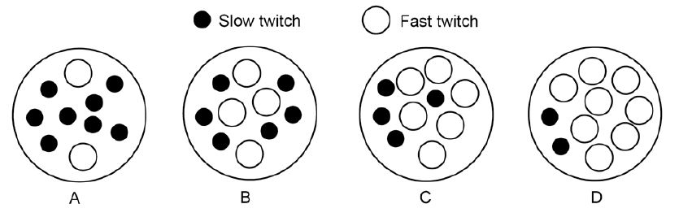
- A
- B
- C
- D

4. The energy used by muscles to contract and produce movement comes from a chemical compound called:

- Adenosine Triphosphate (ATP)
- Creatine Phosphate (CP)
- Adenosine Diphosphate (ADP)
- Lactic Acid

5. The energy used by a runner to complete a 400m sprint is primarily provided by the:

- Aerobic System
- Lactic Acid System
- Muscles stores of ATP
- ATP-CP System

6. Which of the following muscles produces extension at the elbow?

- Deltoids
- Biceps
- Quadriceps Group
- Triceps

7. In completing their event a 5000m runner obtains energy for their muscles:

- From their aerobic energy system
- From their anaerobic energy systems
- From an even contribution by the aerobic and anaerobic pathways
- Primarily from their aerobic energy system with some contribution from their anaerobic energy systems

8. In the sport of rugby, the ball carrier has to react to the defence quickly, often changing his initial running direction. This is a characteristic of which component of fitness?

- Muscular strength
- Agility
- Muscular power
- Flexibility
.

9. The primary food fuel for energy production during high intensity physical activity is

- PC
- Protein
- Fats
- Carbohydrates

10. ‘You get what you train for’ is a phrase that could be expressed more correctly by the term:

- Overload
- Specificity
- Intensity
- Training effect

11. For an athlete to increase muscular strength, he/she should:

- Use heavy weights with many repetitions
- Use light weights with many repetitions
- Use heavy weights with few repetitions
- Use lights weights with few repetitions
12. Which of the following statements about the mechanics of breathing is correct?

- Inhalation is caused by the stimulation of alveoli muscle, resulting in a vacuum in the lungs for an air inflow
- Inhalation is caused by the contraction of the diaphragm muscle, which increases the chest volume and in turn creates a negative pressure for air inflow
- Inhalation is a passive process involving the stimulation of the alveoli and the
relaxation and flattening of the diaphragm muscle
- Inhalation is a passive process involving the relaxation of the lung and alveoli tissues to open the airways for air inflow

13. Which of the following are both an immediate response and a long-term adaptation to
exercise?

- Increased stroke volume
- Increased blood flow to the muscles
- Increased arterial – venous O₂ difference
- All of the above

14. An athlete is said to be in oxygen deficit when their oxygen uptake is:

- less than the oxygen required to produce sufficient energy aerobically
- greater than the oxygen required to produce sufficient energy aerobically
- equal to oxygen required to produce sufficient energy aerobically
- below resting oxygen levels to produce energy aerobically

15. Which of the following is not an immediate response to exercise?

- Increased respiratory rate
- Increased blood pressure
- Decreased resting heart rate
- Decreased creatine phosphate stores

16. Blood flow changes are an immediate response to exercise. Which of the following parts of the body would you expect to have decreased blood flow in response to running?

- Skeletal muscles
- Heart
- Skin
- Abdominal organs

17. Which of the following does not occur during recovery from exercise?

- Removal of lactic acid
- Replenish ADP stores
- Supply oxygen to the heart and respiratory muscles
- Supply oxygen to the body tissues

18. Which muscle group is primarily responsible for flexion, internal rotation and adduction of the arm?

- Pectoral muscle
- Deltoid muscle
- Trapezius
- Latissimus Dorsi

19. The tibialis anterior muscle contracts to cause which of the following movements of the ankle joint?

- Pronation
- Dorsi flexion
- Plantar flexion
- Rotation

20. The amount of air inhaled or exhaled with one breath is referred to as:

- Respiratory rate
- Stroke volume
- Gaseous exchange
- Tidal volume

END OF SECTION ONE
SECTION TWO: SHORT ANSWER (50 MARKS)

There are eight questions in this section. Attempt all questions.

Write your answer in the space provided. If room is insufficient, complete the question on the pages provided at the back of this booklet. Ensure that you clearly identify each answer.

Suggested working time for this section is 70 minutes.

Question 1 (12 marks)

The human body uses 3 Energy Systems to provide the energy needed to re-form ATP. Complete the following table to show the duration, fuel used and by-products of each system plus an example of an athletic event that primarily uses each system.

Energy System | Duration | Fuel Used | By-products | Example

Question 2 (6 marks)

Using the quadriceps and hamstrings muscles as examples, explain how muscles work in pairs to produce coordinated movement.

_____________________________________________________________________
_____________________________________________________________________
_____________________________________________________________________
_____________________________________________________________________
_____________________________________________________________________
_____________________________________________________________________
_____________________________________________________________________
_____________________________________________________________________
_____________________________________________________________________
_____________________________________________________________________
_____________________________________________________________________
_____________________________________________________________________
_____________________________________________________________________

Question 3 (10 marks)

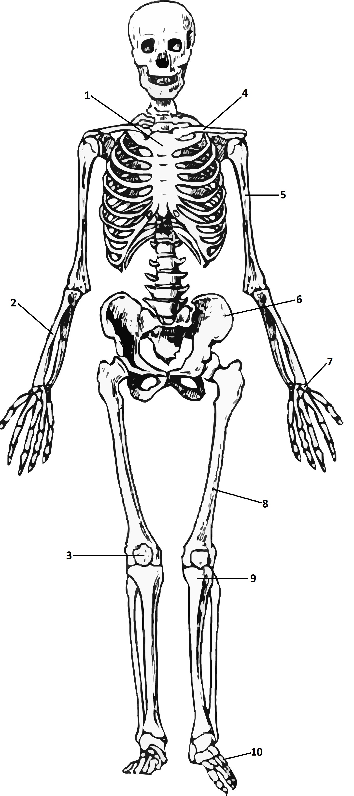
Label the bones on the diagram below.

Question 4 (4 marks)

Identify and briefly explain the different factors that make gas exchange in the lungs possible.

_________________________________________________________________________________________________________________________________________________________________________________
___________________________________________________________
___________________________________________________________
Question 5 (9 marks)

Label the muscles on the diagram below.

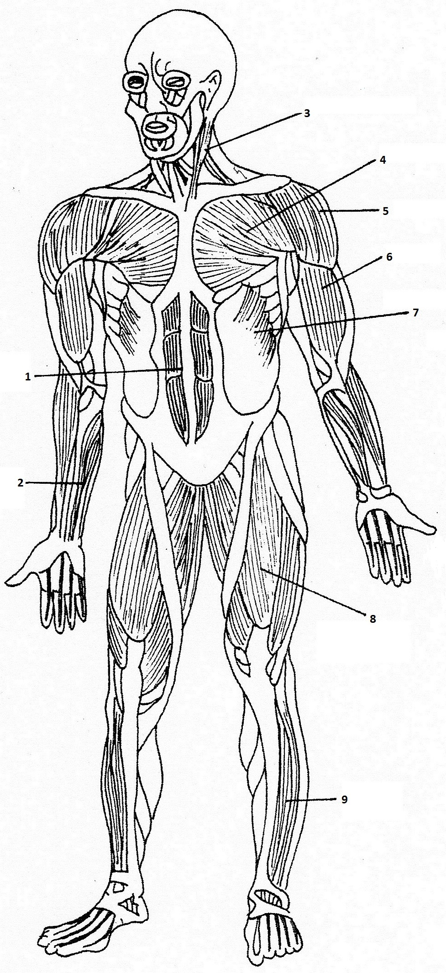

Question 6 (5 marks)

- Label the 2 blood vessels on the diagram below. (2 marks)

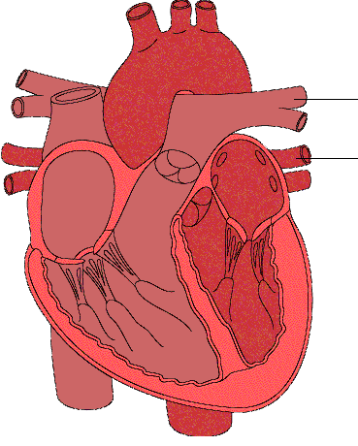

- State the function of each blood vessel. (3 marks)
_______________________________________________________________________________________________________________________________________________________________________________________________________________________________________________________________________________________________________

Question 7 (4 marks)

List the 4 primary components of blood.
_____________________
_____________________
_____________________
_____________________

END OF SECTION TWO
SECTION THREE: EXTENDED ANSWER (30 MARKS)

There are four questions in this section. Attempt two questions.

Write your answers on the lined pages provided at the back of this booklet. Ensure that you clearly identify each answer.

Suggested working time for this section is 60 minutes.

Question 1 (15 marks)

The fitness required to be an elite endurance athlete such as a marathon runner is developed over many years of training.

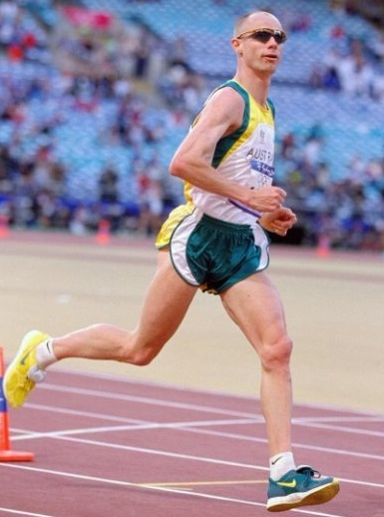

- Identify and describe 5 important long term adaptations to training for marathon runners and explain how these adaptations will enhance performance.
(7 marks)

- Describe the methods of training that would be used and the principles of training that would be applied in a training program for a marathon runner. Provide a reason for each of your answers.
(8 marks)

and/or

Question 2 (15 marks)

The energy system and components of fitness requirements within a particular sport can alter depending on the different demands of different playing positions.

Select a sport that you are familiar with and, using examples, discuss how and why the energy system and components of fitness requirements are different for two different playing positions within that sport. Include in your answer a description of the two different playing positions.

and/or

Question 3 (15 marks)

The pre-season training program outlined below has been designed to prepare a team sport (e.g. soccer, netball, football) player for the start of a new season. No other training sessions have been prescribed for the player in addition to those outlined in the program below. Use the data in the training program below to answer the questions that follow.

 | Sun | Mon | Tues | Wed | Thur | Fri | Sat
Week 1 |  | 10 min jog |  | 10 min cycle |  | 10 min swim | 10 min jog
Week 2 |  | 11 min jog |  | 11 min cycle |  | 11 min swim | 11 min jog
Week 3 |  | 20 min jog |  | 20 min cycle |  | 20 min swim | 20 min jog
Week 4 |  | 22 min jog |  | 22 min cycle |  | 22 min swim | 22 min jog

- Explain why the pre-season training program is inadequate in terms of the principles of training that have not been correctly applied in the program. (6 marks)

- Identify 3 training methods that have not been used in the program that a pre-season team sport program should include. Explain why these training types should be incorporated into the program. (9 marks)

and/or

Question 4 (15 marks)

Explain the different reasons why it is unlikely that an Olympic 100m sprint champion would be competitive in an Olympic 10,000m race. Discuss reasons relating to anatomy (structure), physiology (function) and training in your explanation.

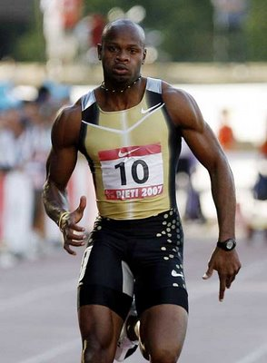  100m Sprinter | 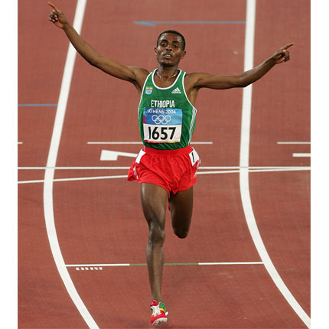  10,000m Runner

End of Questions

